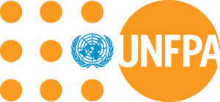

Annex IV: Timeline
The purpose of the timeline is to provide UNFPA with an indication in time of the proposed project flow, intervention per intervention, to assess feasibility and efficiency. The timeline below aims at covering a maximum of 12 months: from January to December 2022. Please indicate the activities (and sub-activities) to carry out on the left column and color the relevant month(s) in which each activity will be implemented according to the plan.

Detailed Implementation Plan | Jan | Feb | Mar | Apr | May | June | July | Aug | Sept | Oct | Nov | Dec

